12th January 2015

**Successful weekend for YOKOHAMA at Autosport International**

***The Japanese manufacturer of high-performance road and motorsport tyres, YOKOHAMA, enjoyed a successful weekend at this year's Autosport International show.***

YOKOHAMA has been a regular at the show for decades, as Autosport tends to be the launch pad for many motorsport programs, as well as incorporating the Performance Car Show in recent years.

This provides YOKOHAMA with a unique opportunity to promote not only its wide motorsport involvement but also, its range of high performance, replacement and 4x4 tyres to one of its key groups of consumers.

This year, the YOKOHAMA stand was located in its traditional spot, as the first that visitors are presented with as they use the show's main entrance.

The manufacturer had its range of motorsport tyres on display, including track, rally and rally cross along with its full range of road-going tyres. Experts were on hand to discuss customer requirements for road and motorsport at all levels.

YOKOHAMA also had Ollie O'Donovan's Ford Fiesta R5 Rallycross car on display, which he will use in the 2015 British Rallycross Championship.

Commenting, Yokohama HPT Ltd. Managing Director David Seward, said; "Once again, the Autosport International show was a great success for us. This is the third decade we have been at the show and it never fails to deliver. The crowds were huge over the weekend and once again, we found ourselves in prime position.

"There was huge interest in our products, as usual, as well as for Ollie's car and we look forward to supporting him in this year's championship."

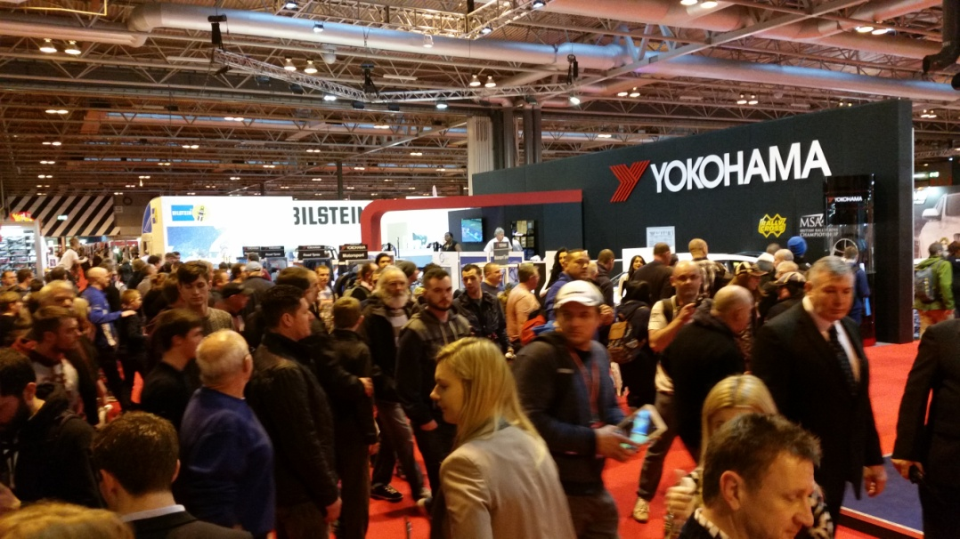

*The YOKOHAMA stand at the 2015 Autosport International show, just inside the main entrance*

***About Yokohama HPT Ltd.***

Yokohama HPT Ltd. is the UK distributor of passenger car, 4x4 and motorsport tyres from Japanese manufacturer YOKOHAMA, along with replacement alloy wheels from TSW and several marque-specific ranges for BMW, Mercedes, Porsche, Land Rover and Jaguar cars.

Supplying to the retail trade, Yokohama HPT Ltd. has built its products into market-leading brands, enjoying particular success in the high performance car sector and is always keen to further develop its network of dealers for even greater market coverage.

Operating from purpose-built premises, Yokohama HPT Ltd. is able to offer guaranteed next-day delivery and a team of enthusiastic and highly-trained sales staff, who provide an efficient sales and technical service. Yokohama HPT Ltd. believes its operation is unique, offering customers a one-stop shop for performance tyres and alloy wheels.